**Comparing Worlds Project**

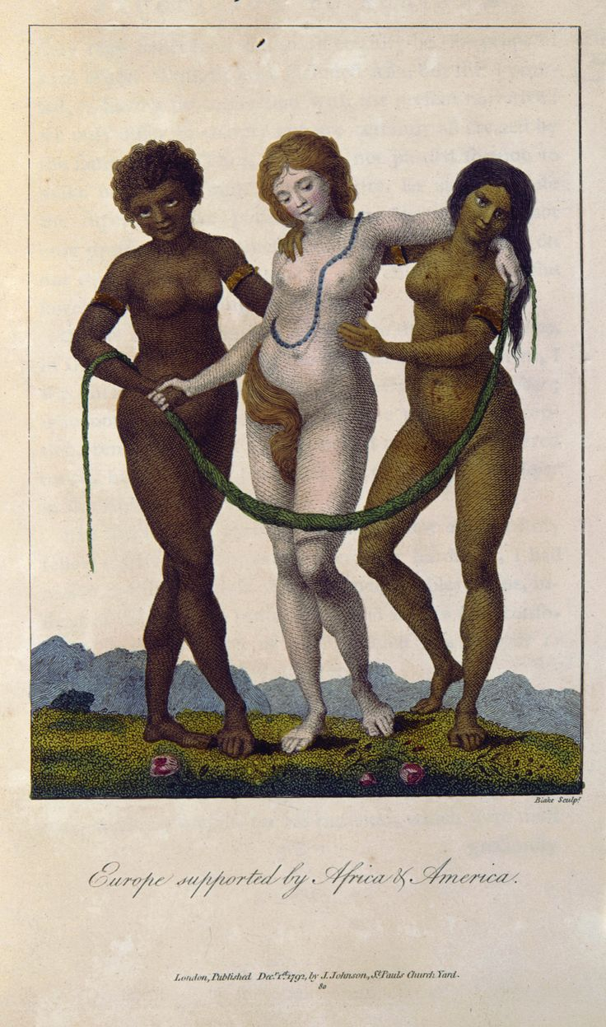 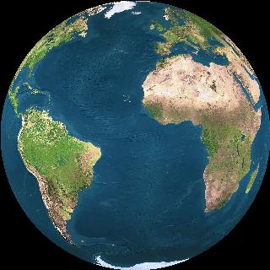

**Objective**: The goal of this project is to take a close look at one aspect of human life and analyze the similarities and differences between how it looked in different parts of the Atlantic region (ideally parts of all 4 continents) before the year those regions came into continuous contact. This is an “Analyze” question, so you must discuss the *how* & *why*.

**Topic and Research**: Start with one of the SPICE categories and narrow down your topic to something manageable. Some suggestions are given below. You must use ***at least*** two primary source documents and employ (in total) ***at least*** five reliable sources in your research. Primary sources from the period after contact are acceptable insofar as they document what existed before substantial cultural mingling occurred.

**Artifact of Learning**: Projects may be presented in a number of mediums (check with your teacher), but all must clearly state a thesis (about similarities and differences), provide ample supporting evidence for claims (including quotes or direct references to primary sources), and include a **Chicago style annotated bibliography**.

Some possible topics (but please feel free to propose your own!):

* Role of religious leaders in society
* Observation of religious rituals
* Agricultural practices
* Technological developments (choose a specific purpose technology serves)
* Gender roles
* Relationship with animals
* Primary trade goods
* Conduct of trade
* Housing
* Luxury items
* Social class hierarchies
* Family structure
* Dress or hairstyles and their significance
* Creation stories
* Labor systems
* Use of art to portray power
* Works of monumental architecture
* Understanding of land ownership

**Rubric**

|  |  |  |  |  |
| --- | --- | --- | --- | --- |
|  | **Novice** | **Developing** | **Proficient** | **Advanced** |
| **Argument** | Student does not make an argument or goes off topic. | Student’s thesis is vague or unclear. Argument may change or waver. Student does not explicitly address similarities or differences. | Student states a thesis that responds to the question and maintains the argument throughout. Identifies similarities and differences. | Student clearly states thesis in Introduction and defends it throughout. Argument analyzes *causes* of sims/diffs. |
| **Use of Evidence** | Student makes excessive number of claims without support. | Student doesn’t use primary sources or includes sources without analysis. | Student uses a variety of sources to back claims. May use the minimum or have some points unsupported. | Appropriate quotes and supporting evidence are employed throughout the speech to back all claims. Ample primary sources. |
| **Delivery / Presentation** | For **Speech**: is articulated clearly and with appropriate volume ☐. Easy-to-follow organization of argument☐. Tone is conversational but academic☐. Avoids “like”, “um”, and “uh” ☐. Pacing is steady☐.  For **Paper**: employs sophisticated compositional skills ☐. Avoids grammar, syntax, and spelling mistakes ☐. Well-organized☐.  For **Presentation, PPT, Voicethread, Video**: creative use of visuals to enhance argument☐; correct grammar/spelling ☐; no filler words☐;  clear articulation ☐ with appropriate volume☐ and steady pace☐; easy-to-follow argument☐. | | | |
| **Research and Citation** | Student only compares two continents. Lacking necessary citation. | Some serious issues with citation. Research/speech may treat continents unequally. | Student’s research focuses on 3 continents. Sources are cited in written work with only minor formatting errors. | Student addresses all 4 continents in research & final project. All sources cited properly in oral & written work. |

**Assignment ready on time? Y N**